Definition

Prompting is any support/cue given to help a student perform a specific behavior and/or complete a specific task. Priming is a strategy used to prepare a student for an upcoming activity/exception/routine/ demand, etc. by giving them relevant information and/or rehearsing prior to when the specific behavior/task occurs. In essence, priming is a heads-up.

Add Stimulus

sup

Strategies and Tips
PROMPTING

Prompt Hierarchy
Prompting has a least to most invasive/restrictive hierarchy that is important to understand.
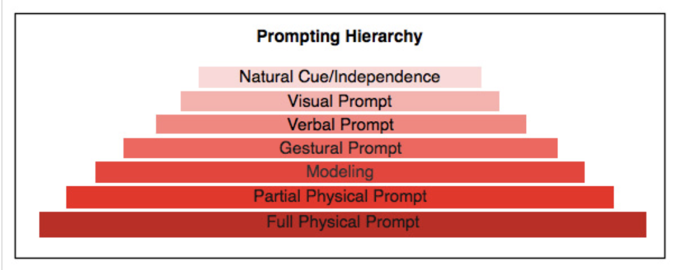

Tailor to Individual Needs
Prompts should be individualized to meet the individual needs of each student. This includes understanding how to move up and/or down the prompt hierarchy across goals and student needs on a daily basis in a consistent and calm manner.

Monitor Prompting
Be sure to monitor how/when and frequency of prompting to not only prevent over prompting but also avoid prompt dependency. Be sure to provide concrete opportunities for more independence/less intrusive prompts when the student is regulated. If the student begins to struggle, just return to the previous prompt level. To fade prompts, we first need to monitor.

Add Stimulus

Add Stimulus

Add Stimulus

PRIMING

Dress Rehearsal/Heads Up
Priming is essential rehearsing for the upcoming action/behavior/expectation. Another way to consider priming is a heads up about what is about to happen and how to respond versus react.

Combine Them
Priming and prompting often occur together. For example, a student can be primed for how to raise their hand during circle time right before the transition. Then during the circle time staff can actively monitor for when to use a gestural prompt to support the student’s use of hand raising.

Visual Supports
Using visual cues to highlight steps/expectations of the following activity/routine can really help students be more successful and prevent escalation.

Social Stories
Developing personalized stories that highlight the main components of the activity/routine and expectations related to behaviors help students understand social cues and manage different stressors as they arise.

Add Stimulus

Add Stimulus

Things to Avoid:
- Not monitoring prompt hierarchies or providing opportunities for prompting fading and independence building. Consider how current prompting practices building support or limit independence.
- Thinking that the student is “just not trying hard enough” because they continue to require prompts and priming.
- Not providing concrete opportunities to develop independence and fading.
- Not priming when changes are going to occur. Even the slightest changed can benefit from students becoming prompt dependent.

Staff Self-Management
Reflection

How do I typically prompt/prime the students I support?
_______________________________________

_________________________________________

_________________________________________

How effective are my current prompting/priming

practices?_________________________________

_________________________________________

_________________________________________

What student behaviors am I mainly using

prompting and priming for?____________________

_________________________________________

_________________________________________

When am I mainly prompting/priming (e.g., time,

schedule, transition)?_________________________

_________________________________________

_________________________________________

Which two prompting/priming strategies am I going to

focus on scaling up?________________________

_________________________________________

_________________________________________

_________________________________________

_________________________________________

Add Stimulus

Add Stimulus

Add Stimulus

Skill Use

Prompting strategy #1:

_________________________________________

Priming strategy #2:

_________________________________________

On a daily basis, check off the box if you practiced using the strategies you are scaling up. Remember, this is not evaluatory. This is about focusing on skills that will help you as an educator.

Week #1
Strategy | M | T | W | Th | F
Successes & Barriers:

Week #2
Strategy | M | T | W | Th | F
Successes & Barriers:

Week #3
Strategy | M | T | W | Th | F
Successes & Barriers:

Week #4
Strategy | M | T | W | Th | F
Successes & Barriers:

Add Stimulus

Add Stimulus

Add Stimulus

